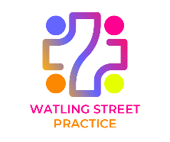
WSP PPG meeting February 10th 2026 12-30 to 2-0pm
Hilltop medical centre, Kensington Drive, Great Holm, MK8 9HN

Agenda
- Welcome, introductions and apologies

- Minutes of meeting on November 25th

- Matters arising

- Covid and Flu vaccinations (JW,EB)

- Communications (JW,EB)

- Rapid Health system (JW,EB)

- Progress report on General Practice Improvement Programme (JW,EB)

- Drop in session (SH)

- APPG report (DH)

- Terms of reference (SH)

- Election of Vice Chair (SH)

- Car parking at Great Holm (parish council MC) (local businesses, JW,EB)

- Staffing (EB)

- Collaborative working (JW)

- Matters raised by PPG members

- Communications within and between WSP, the PPG and patients more generally

- The WSP website

- Issues related to making appointments

- Ordering repeat prescriptions

- Report from Watling Street Practice

- AOB (please contact the Chair David Outtram before the meeting).

- Dates of Next Meetings: 12th May, 11th August, 10th November

